EMR DHIS2 Connector

Two-Sentence Overview
The goal of this project is to connect Electronic Medical Record (Bahmni) to DHIS2 to allow for a longitudinal view of patient-level data and better assess project implementation, coverage, and impact. The connector will be built and tested through an HIV linkage to care project based in Zimbabwe that tracks clients across different locations and service provision.

Executive Summary
Population Services International (PSI) would like to partner with ThoughtWorks to develop a "connector" between DHIS2, a health management information system (MIS), and electronic medical record tools, ie Bahmni. The connector will make it easy to send Electronic Medical Record (EMR) data to DHIS2 allowing health program managers to quickly generate dynamic and powerful client profiles and information to better communicate data and inform health program strategy.

This proposed connector actively supports progress against the Global Goods Maturity Model for Digital Health Software Tools. This connector promotes interoperability and data accessibility by providing a means for data to be more readily visualized and understood. The connector also has global utility as both ministries of health and health organizations both already use DHIS2 as an MIS and EMR tools like Bahmni.

Over 60 countries and 40+ organizations are using DHIS2 as its management information system. DHIS2 helps governments and health organizations like PSI to manage their operations more effectively, monitor processes, and improve communication. PSI is the largest NGO implementer of DHIS2 and works closely with UiO to further develop the platform.

Electronic Medical Record tools like Bahmni provide a space where users can record confidential client information and create long term and complete records of health history without having to depend on information technology staff or database administrators. Via this proposed connector, the data will be pulled directly from Electronic Records to DHIS2. Any Electronic Medical Record tool would benefit from the option of having a DHIS2 connector.

As proof of concept that EMR data can easily be imported into DHIS2, we propose to build a simple DHIS2 connector for Bahmni. Bahmni is already free and open source. There is currently no connector for DHIS2 in Bahmni. Off-the-shelf Electronic Medical Record tools are easy-to-use, impactful, and effective tools for health ministries and health organizations. Data storage and analysis features in DHIS2 could provide more in-depth technical information on clients to allow users a more in-depth idea of client profile, tracking across the continuum, and linkage to care.

Consortium Team
About PSI team:
Role: Project Manager
PSI is a leading global health organization with programs targeting malaria, FP, RH, and HIV/AIDS and more. Active in more than 65 countries, PSI is a thought leader in DHIS2, implementing DHIS2 across its platforms and supporting Ministries of Health and partners in 20 countries to design HMIS, using DHIS2. PSI is a global leader in DHIS2 implementation and using data for decision-making. Through our very close collaboration and significant influence with the University of Oslo (developers of DHIS2), we have directly proposed and influenced the development of features that benefit the entire community of DHIS2 users, including 40+ MOHs and NGOs using the platform. PSI received InsideNGO’s Operational Excellence Award Winner for Information Technology in 2015 and was one of the founding partners of the annual DHIS2 Symposium, the only DHIS2 conference held in the United States.
About ThoughtWorks:
Role: Developer
ThoughtWorks is a software company and a community of passionate, purpose-led individuals. At ThoughtWorks, we think disruptively to deliver technology to address our clients' toughest challenges, all while seeking to revolutionize the IT industry and create positive social change.
ThoughtWorks Global Health experience:
ThoughtWorks has a long experience in creating and contributing to technology for social needs, especially in Global Health. Bahmni (an EMR based on OpenMRS) was created by ThoughtWorks as a free open-source software and is now used in over 40 countries and is regarded as a global good software. A concept of Shared Health Record (SHR) and Health Information Exchange (HIE) was created and demonstrated for Ministry of Health, Bangladesh by ThoughtWorks.ThoughtWorks was the development partner in delivering the 1st version of OpenLMIS software, which is a free open-source logistics management software. Please refer to other work of ThoughtWorks in global health at the link .

Project Description
The approach taken to build out the technical solution will be the following:
- Aligned approach through community engagement of the following global good software: Bahmni, OpenMRS and DHIS2
- Embracing standards – HL7 FHIR, ICD10, ICD11, SNOMED etc.
- Demonstrate value by building the solution stage by stage and using it on the field.
- Making the solution scalable for use.
Deliverables & Schedule
The current project to provide accurate HIV indicator reporting through the use of Bahmni (as EMR) and DHIS2 (as HMIS). This approach is similar to the “Standalone” maturity described in the Whitepaper. This is currently being implemented by PSI Zimbabwe and is expected to be completed by June 2019.
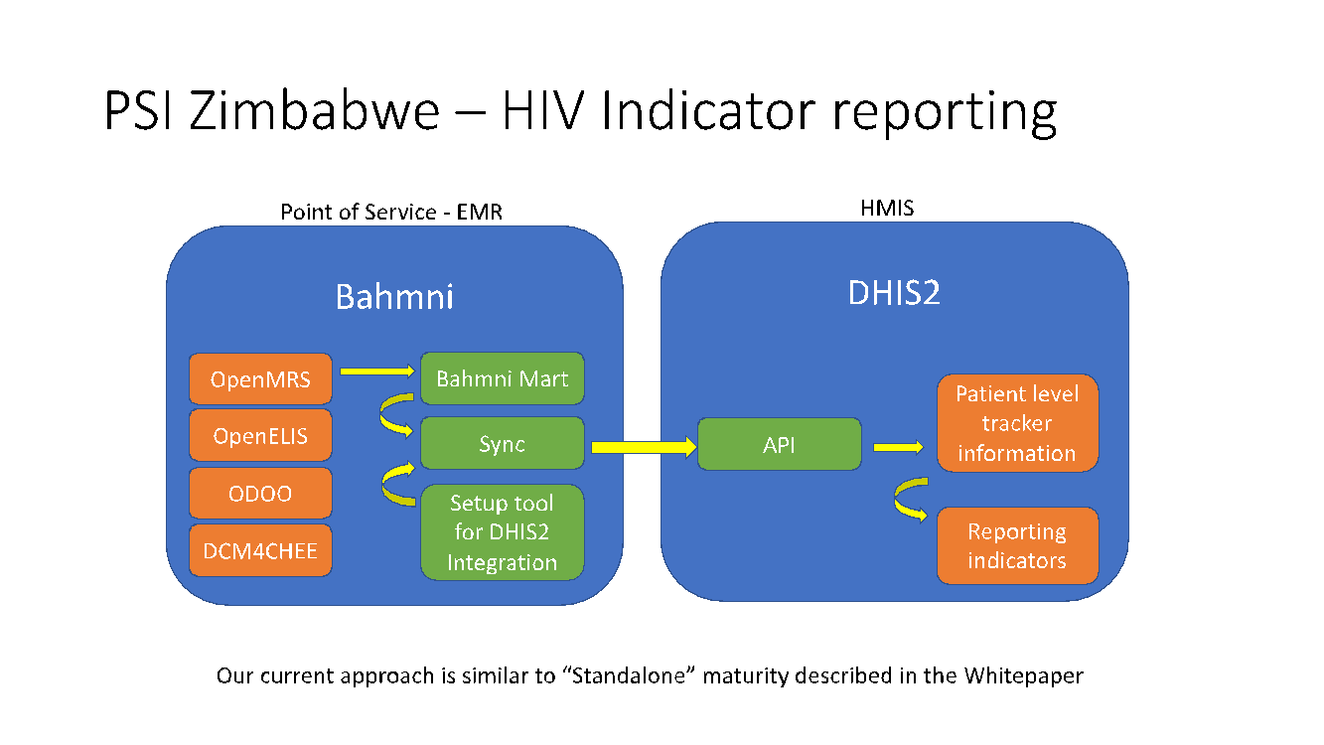
We are proposing to move this approach to “Integrated” maturity as described in the Whitepaper in 3 stages
- Stage 1: Create FHIR server containing components as described in the OpenHIE framework. The components are described in the diagram below. Also, an integration will be built and demonstrated between Bahmni (EMR) and the FHIR server by using the HL7 FHIR resources. All this will be done in parallel to the existing implementation at PSI Zimbabwe.
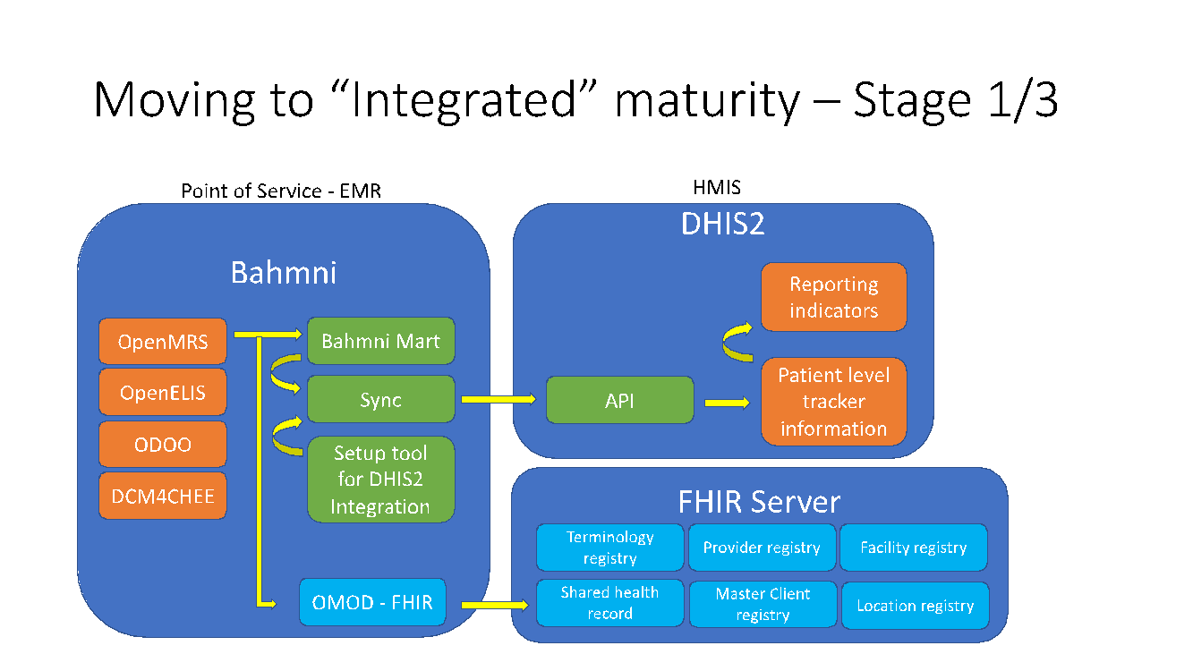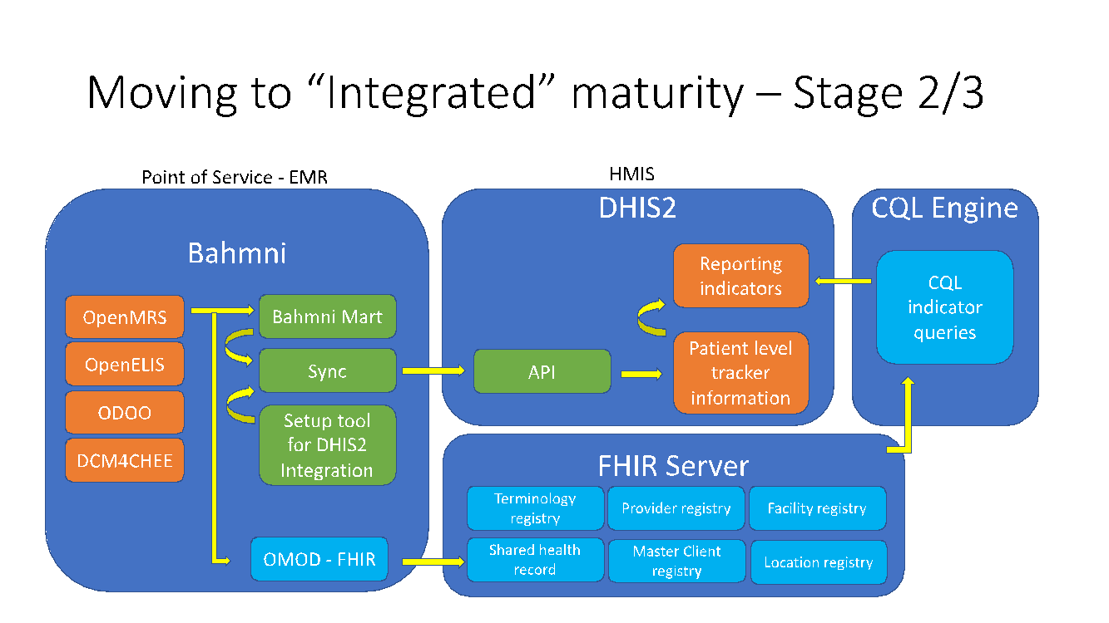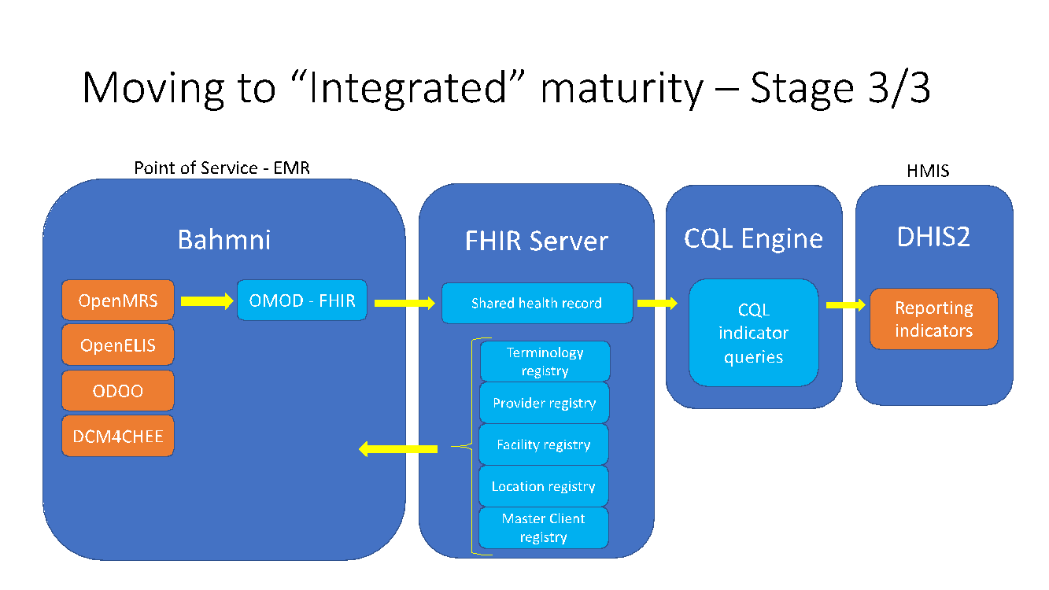
- Stage 2: After successful demonstration of Stage 1, the next step is to demonstrate the reporting of indicators similar to the existing implementation. For this, CQL engine will be built up , queries will be written following standards to report on Indicators. These indicators will be in parallel to the existing implementation to assess accuracy of reporting.
- Stage 3: After the successful demonstration of reporting indicators using the CQL engine, during this stage, automatic sync will be established to ensure that Bahmni (EMR) is always in sync with the data setup in the various registries in FHIR server. Once this is done, it is easy installing and starting up on a new site with Bahmni (EMR) which is easily integrated into this approach. Also, we will decommission the “Standalone” approach and fully move to the “Integrated” approach.
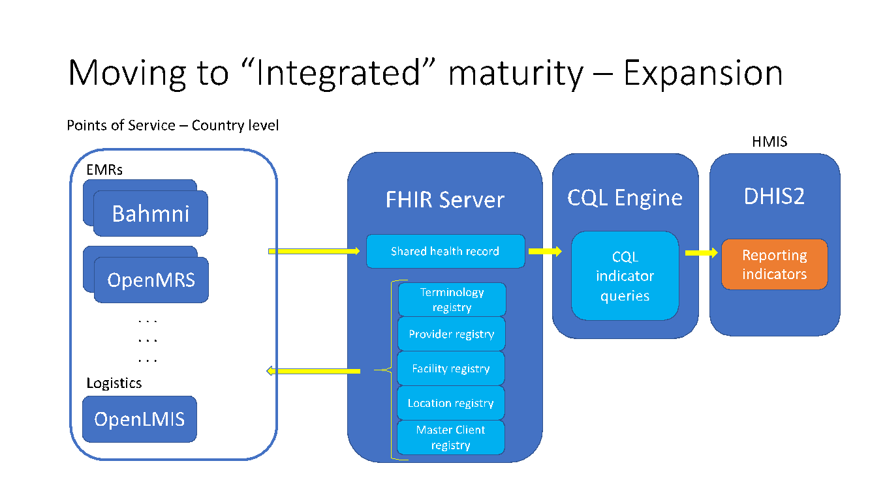
- Expansion: Once the “Integrated” approach is fully demonstrated, we can look at expanding the implementation of Bahmni (EMR) in multiple sites thereby demonstrating value of scaling. Also, different other systems like OpenMRS (EMR), OpenLMIS (Logistics) etc. could be integrated into this solution.

S. No. | Risk | Mitigation | Comments
1 | Open-source products (Bahmni, OpenMRS) will need community engagement and hence could lead to delays in completion of technical design/development. | Adequate time to be factored for community engagement and reasonable buffer in the case of delays | In the case of delays over the expected amount, then TW will report and the program team can make suitable adjustments.
2 | Clarity on how the Privacy of patients will be enforced | ThoughtWorks will seek guidance from the community on how Privacy will be enforced on the solution.
3 | Demonstrating the generic solution | ThoughtWorks will be working with PSI Zimbabwe to initially demonstrate the solution, however, it would be good to identify if there are other organizations interested in piloting this solution.
Risk Mitigation

