## Two-Sentence Overview PSI

The goal of this project is to connect Electronic Medical Record (Bahmni) to DHIS2 to allow for a longitudinal view of patient-level data and better assess project implementation, coverage, and impact. The connector will be built and tested through an HIV linkage to care project based in Zimbabwe that tracks clients across different locations and service provision.

## High-Level Budget Summary

*Instructions for the applicant:*

* ***Please leave blank during preliminary application step. This section should be completed in the application finalization step.***

## Executive Summary

[Population Services International](http://www.psi.org/) (PSI) would like to partner with [ThoughtWorks](https://www.thoughtworks.com/) to develop a "connector" between DHIS2, a health management information system (MIS), and electronic medical record tools, ie Bahmni. The connector will make it easy to send Electronic Medical Record (EMR) data to DHIS2 allowing health program managers to quickly generate dynamic and powerful client profiles and information to better communicate data and inform health program strategy.

This proposed connector actively supports progress against the Global Goods Maturity Model for Digital Health Software Tools. This connector promotes interoperability and data accessibility by providing a means for data to be more readily visualized and understood. The connector also has global utility as both ministries of health and health organizations both already use DHIS2 as an MIS and EMR tools like Bahmni.

Over 60 countries and 40+ organizations are using DHIS2 as its management information system. DHIS2 helps governments and health organizations like PSI to manage their operations more effectively, monitor processes, and improve communication. PSI is the largest NGO implementer of DHIS2 and works closely with UiO to further develop the platform.

Electronic Medical Record tools like Bahmni provide a space where users can record confidential client information and create long term and complete records of health history without having to depend on information technology staff or database administrators. Via this proposed connector, the data will be pulled directly from Electronic Records to DHIS2. Any Electronic Medical Record tool would benefit from the option of having a DHIS2 connector.

As proof of concept that EMR data can easily be imported into DHIS2, we propose to build a simple DHIS2 connector for Bahmni. Bahmni is already free and open source. There is currently no connector for DHIS2 in Bahmni. Off-the-shelf Electronic Medical Record tools are easy-to-use, impactful, and effective tools for health ministries and health organizations. Data storage and analysis features in DHIS2 could provide more in-depth technical information on clients to allow users a more in-depth idea of client profile, tracking across the continuum, and linkage to care.

## Consortium Team

**About PSI team:**

*Role: Project Manager*

PSI is a leading global health organization with programs targeting malaria, FP, RH, and HIV/AIDS and more. Active in more than 65 countries, PSI is a thought leader in DHIS2, implementing DHIS2 across its platforms and supporting Ministries of Health and partners in 20 countries to design HMIS, using DHIS2. PSI is a global leader in DHIS2 implementation and using data for decision-making. Through our very close collaboration and significant influence with the University of Oslo (developers of DHIS2), we have directly proposed and influenced the development of features that benefit the entire community of DHIS2 users, including 40+ MOHs and NGOs using the platform. PSI received InsideNGO’s Operational Excellence Award Winner for Information Technology in 2015 and was one of the founding partners of the annual DHIS2 Symposium, the only DHIS2 conference held in the United States.

**About ThoughtWorks:**

*Role: Developer*

ThoughtWorks is a software company and a community of passionate, purpose-led individuals. At ThoughtWorks, we think disruptively to deliver technology to address our clients' toughest challenges, all while seeking to revolutionize the IT industry and create positive social change.

*ThoughtWorks Global Health experience:*

ThoughtWorks has a long experience in creating and contributing to technology for social needs, especially in Global Health. [Bahmni](https://www.bahmni.org/) (an EMR based on OpenMRS) was created by ThoughtWorks as a free open-source software and is now used in over 40 countries and is regarded as a global good software. A concept of Shared Health Record (SHR) and Health Information Exchange (HIE) was created and demonstrated for Ministry of Health, [Bangladesh by ThoughtWorks.](https://www.thoughtworks.com/clients/dghs-bangladesh)ThoughtWorks was the development partner in delivering the [1st version of OpenLMIS software](http://openlmis.org/about/history/), which is a free open-source logistics management software. Please refer to other work of ThoughtWorks in global health at the [link](https://www.thoughtworks.com/global-health) .

## Background or Problem Statement

## Digital Health Technologies

## Use Cases and User Stories

Primarily, we are looking at 90-90-90 metrics calculation and reporting for HIV

1st 90: 90% of HIV case status is known to patients

In the reporting period, Result of HIV test communicated to new patients / No. of HIV tests done on new patients

2nd 90: 90% of HIV +ves cases are on ART (Anti Retroviral Treatment)

In the reporting period, No. of new HIV +ves on ART / No. of new HIV +ves

3rd 90: 90% of HIV +ves cases on ART are virally suppressed

In the reporting period, No. of HIV +ves virally suppressed / No. Of new HIV +ves on ART (present at least for 3 months)

**NOTE:** Suggested solution is described in the Appendix A

## Objectives and Activities - Thoughtworks

Objective:

* Demonstrate the collection of Longitudinal records for HIV from a Point of service system (Bahmni) and automatically report on the 90-90-90 metrics from the information collected using a standard calculation mechanism

Follow-on objectives:

* Demonstrate functional scaling to other programs (e.g.) TB or Family planning subsequently
* Demonstrate scaling by using another Point of service system (OpenMRS) subsequently

HIV Workflow at PSI Zimbabwe:

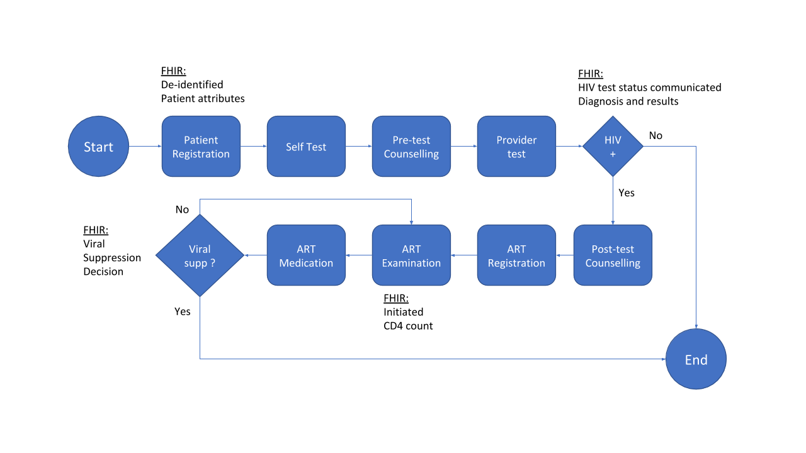

Key activities:

* Build the HIV workflow in the Point of service (Bahmni)

* Build the indicated integration to send information from Point of Service to FHIR server using FHIR HL7 resources version R4 (restricted to Minimum Data Set needed to generate 90-90-90 metrics). As part of this FHIR server needs to be deployed to store the longitudinal records sent by Point of service.

* Using the information in FHIR server, develop and deploy CQL scripts to calculate and send 90-90-90 indicator information to HMIS system (DHIS2) using mADX format. As part of this a CQL engine needs to be deployed to understand and execute the CQL scripts.

* Visualise the indicator data trend in HMIS system (DHIS2).

### Work package 1:

## Community Feedback

## Schedule

The following is a high-level work plan.

|  |  |  |  |  |  |  |  |
| --- | --- | --- | --- | --- | --- | --- | --- |
| **Activity** | **Team**  **Location**  **Month/ Quarter** | **[Month/Quarter** | | | | | |
| [M] | [M] | [M] | [M] | [M] | [M] |
| 1 | 2 | 3 | 4 | 5 | 6 |
| [Plan work and collect documentation] | [Org, USA] | x |  |  |  |  |  |
|  |  |  |  |  |  |  |  |

## Deliverables-

|  |  |
| --- | --- |
| **Deliverable** | **Month/Quarter Due** |
| [Work Package 1, Objective 1, Activity 1 output, “Finalized link to X”] | [M3] |
|  |  |
|  |  |

## Global Good Maturity Model Assessment - PSI

*Instructions for the applicant:*

* *Complete the self-assessment and include the* [*link*](https://docs.google.com/spreadsheets/d/16nZHBsb6Zjsh9T_7Fj7zvMXUspjh39CNSS76UT6WHJU/edit?usp=sharing) *to the Google Sheet. You do not have to reach a certain threshold on the Maturity Model to qualify for funding through the Notice. If you would rather, you may attach the self-assessment in the “Attachments” in OAP&P as an Excel document.*

Please review [“Attachments” on OAP&P.” ***or*** [updated link](https://docs.google.com/spreadsheets/d/16nZHBsb6Zjsh9T_7Fj7zvMXUspjh39CNSS76UT6WHJU/edit?usp=sharing).”]

# Appendix A

## Solution

We propose to create an integrated ecosystem which consists of multiple components spread across the IHE.

The proposed solution consists of distinct central systems used for storing Patient Longitudinal Record, Master Data Management and Reporting to HMIS. There will be individual EMR Instances which will be used at Point of Service to capture patient data.

The diagram below presents a view of the components which will be present in the ecosystem.

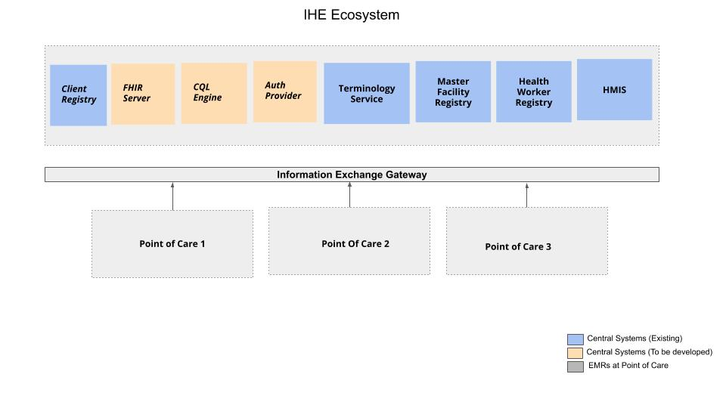

Below is a detailed description of the components:

### Client Registry

The Client Registry can be used to maintain consistent, accurate and current demographic and essential medical data on the patients seen and managed. Each patient is assigned a unique identifier that is used to refer to this patient in the whole ecosystem. The objective is to ensure that each patient is represented only once across all the software systems used within the ecosystem.

Client Registry contains personal information, demographic details and family information serving as patient registry.

***Assumption:*** *The Client Registry is already present and the EMRs need to start using it.*

### FHIR Server

The FHIR-Server will serve as the data warehouse and will store the patient longitudinal record. It will be complaint with HL7 FHIR and will work as a repository for all the EMRs. The transactional data from the EMRs will be pushed to this repository and will be used for reporting from this repository.

We can leverage [FreeSHR](https://github.com/SharedHealth/FreeSHR), an existing Open Source Java FHIR server compatible with FHIR STU 3.

### CQL Engine

The CQL engine will be responsible for computing the required indicators with the help of configured CQL for the indicators. This will get the Minimum Data Set(MDS) from FHIR server for the required Indicator. The computation will produce the indicator results in mADX format, which will be submitted to HMIS.

### Auth Provider

The Auth Provider is responsible to provide access control to different users for the systems in IHE. All the Users/Systems which need to interact with Central Systems in HIE, needs to be registered with Auth Provider.

### Terminology Service

The Terminology Service is the single source of truth for the terminology used in EMRs at different Point of Service or CQL Reporting. This will be compliant with HL7 FHIR, and will provide standard terminologies (e.g., LOINC, ICD 10) and indicator metadata such as the codesets for disaggregators and the mappings between them as indicator definitions change.

***Assumption:*** *Terminology registry such as OCL is already present and needs to be integrated.*

### Master Facility Registry

The Master Facility Registry maintains health facility data at all places of service, as well as relevant organizational or geographic hierarchies. This can be used by the FHIR Server to validate the incoming data from specific facilities.

***Assumption:*** *The Master Facility Registry is already present and needs to be integrated with other systems.*

### Health Worker Registry

The Health Worker Registry contains metadata and multiple identifiers for health workers, including their deployment. This can be used by the FHIR Server to validate the incoming data from specific health-workers.

***Assumption:*** *The Health Worker Registry is already present and needs to be integrated with other systems.*

### HMIS

The Health Management Information System(HMIS) is used for the reporting of various indicators and visualization. The CQL Engine will submit the computed results from FHIR Server to the HMIS system.

***Assumption:*** *The HMIS is already present and needs to be integrated with CQL Engine.*

### Bahmni as EMR

We propose to use [Bahmni](https://www.bahmni.org/) as an EMR on the Points of service to capture the patient transactional data. Bahmni is an easy to use, complete, open source HIS and EMR that aims to meet the needs of low resource environments by leveraging a tapestry of existing & well established open source products - namely OpenMRS, OpenELIS, OpenERP, Dcm4Che. For the purpose of this project, only the EMR components will be used. However, Bahmni’s Event Driven Architecture enables enhancements of functions through other pluggable components.

We will develop openmrs-module to enable Bahmni to be able to push the transactional data in FHIR Format. We can leverage [OpenMRS-module-bdshrclient](https://github.com/SharedHealth/openmrs-module-bdshrclient), an existing open source openmrs module which can convert openmrs data model to FHIR STU3.

The module will push data to Central Systems in event-driven fashion. The data captured in the system will create event which will be letter picked up by a schedule job to upload. Event Driven Architecture helps us to schedule the data upload at a specific time based on availability of internet, system load etc.

## Data Flow

There are two parts to the data flow.

* From EMR to FHIR Server
* CQL Engine to HMIS

### EMR to FHIR Server data flow

The data flow from EMR to FHIR Server happens in two scenarios.

**HIV Identification:**

The below picture represent the data flow for HIV Identification.

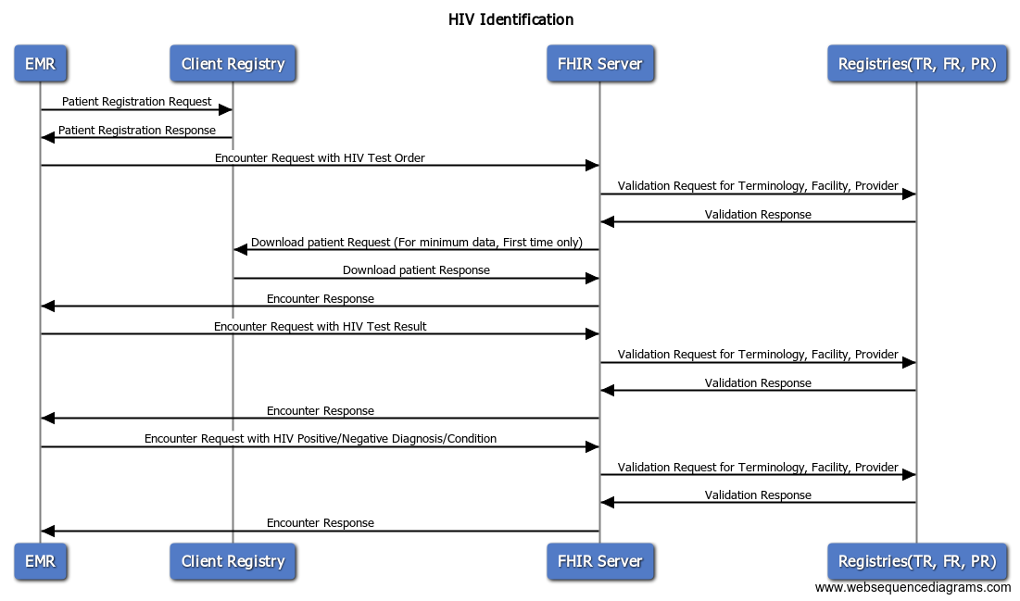

Below example shows the data flow for HIV Identification:

* A Patient visits the Point of Care and gets registered for HIV Test.
* The patient data will be synced to client registry.
* The doctor places a Lab Test Order for HIV.
* The encounter with a Test Order will be uploaded to FHIR Server.
* Before saving the encounter, FHIR Server will ensure with Client Registry the validity of patient and download the minimum patient data. FHIR Server will validate the Terminology, Facility and Provider References against “Terminology Service“, “Master Facility Registry” and “Health Worker Registry” respectively.
* Once the patient HIV Test Results are entered in the system that will be synced as another encounter to FHIR Server.
* After the test results, the patient will be diagnosed with HIV Positive/Negative diagnosis/condition. This data will be uploaded to FHIR Server. This completes the data flow for the HIV Identification.

**HIV ART Therapy:**

The below picture represent the data flow for HIV ART Therapy.

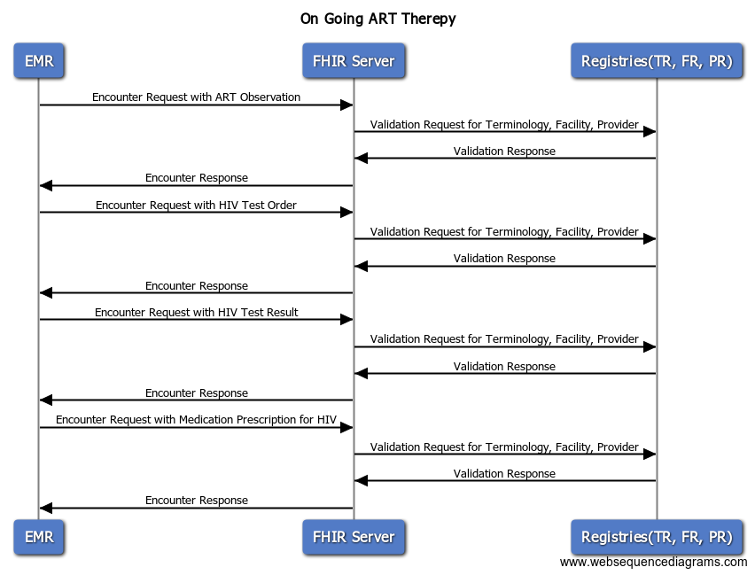

Below example shows the data flow for HIV ART Therapy:

* A Patient already diagnosed with HIV Positive visits the Point of Care for the ART Therapy.
* An ART Observation will be captured for that patient. This will be synced to FHIR-Server as an encounter.
* The doctor places a Lab Test Order for HIV to get the current status of HIV (Viral Load).
* The encounter with a Test Order will be uploaded to FHIR Server.
* Once the patient HIV Test Results are entered in the system that will be synced as another encounter to FHIR Server.
* The patient will be prescribed medication. This will sync to FHIR Server as well.
* The patient visit the hospital again and the same steps will be repeated until the patient test results indicate that the patient has a suppressed viral load.

### CQL Engine to HMIS

The below picture represents the dataflow from CQL Engine to HMIS.

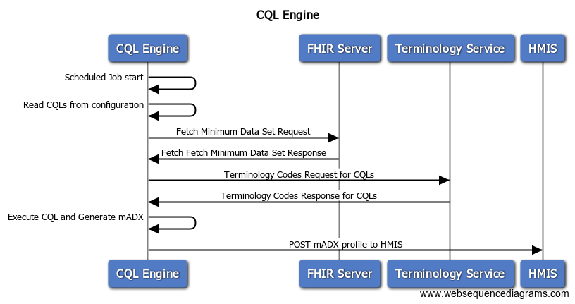

Below steps will happen for reporting an indicator to HMIS from CQL Engine

* A Scheduled Job will read CQL from a specific location.
* It will get the Minimum Data Set from FHIR Server needed for the specific period.
* It will compute results for the CQL with the help of Terminology Service.
* It will generate the mADX message with the computed result.
* The mADX message will be posted to HMIS.

## Technologies

* Bahmni
  + UI - HTML5/CSS3, Angular JS, React JS, jQuery
  + Server - REST APIs, Java, Hibernate
  + Database - MySQL
* FHIR Server
  + Java, PostgreSQL, Spring Framework
* CQL Engine
  + Java, Spring Framework
* Auth Provider
  + Java, Spring Framework