Tamanu: Electronic Medical Record

Two-Sentence Overview
Our goal is to improve healthcare in Pacific Islands through the implementation of Tamanu, our free, open-source, patient-level electronic medical record (EMR) built for the uniquely remote settings across the region, with an offline-first, sync-enabled design across both desktop and mobile. Beyond Essential Systems (BES) is well placed to achieve this goal, as we have in-depth, contextually appropriate experience in delivering successful, transformative digital projects in ten countries across the Asia Pacific Region, with partners including the Australian Department of Foreign Affairs and Trade, the New Zealand Ministry of Foreign Affairs and Trade, WHO, UNFPA and the Bill and Melinda Gates Foundation.

High-Level Budget Summary

Executive Summary
The Digital Square investment will contribute to the continued development of the Tamanu software, improving shelf readiness and reducing the cost of individual deployments. Optimisations will include development of quality assurance and testing frameworks, contribution to the OpenHIE Testing Framework, further documentation of our open-source code repository and further investment into aligning of Tamanu with the OpenHIE architecture. Ideally, this would include mentoring and non-financial support.

As an EMR, the primary goal of Tamanu is to support clinical workflows in low-middle income countries to improve patient care and outcomes, specifically in the Pacific setting. The system must meet the technical and operational challenges that are faced in these settings, whilst aligning with principles of OpenHIE.
Tamanu has been developed by the same software team that developed Tupaia, mSupply and mSupply Mobile, working in collaboration with Sustainable Solutions and designed specifically for the Pacific context.
Tupaia demonstrates the success that has been achieved by BES. It is a data aggregation, analysis and visualisation platform designed to provide a comprehensive map of health systems in the Pacific region. Combining data from DHIS2, mSupply and other sources in real-time, it is used for health supply chain strengthening, disease surveillance, disaster response and strengthening service provision. Tupaia is currently in 10 countries (including 9 in the Pacific) and growing.

Consortium Team
Required: Aligning Tamanu with OpenHIE architecture
This would entail non-financial support for our software development team, ideally through regular remote mentorship sessions and the development of a highly detailed interoperability roadmap.

Prime Organisation: Beyond Essential Systems (BES)
BES is an Australian eHealth company that has managed large projects across the Asia Pacific region. Our software solutions are Tamanu and Tupaia (a multi-award winning open-source health data aggregation and visualisation platform implemented in 10 countries across the Asia Pacific Region). We additionally have extensive experience implementing DHIS2 and mSupply. Development of Tamanu has been led by BES and we will continue to be the primary developer of this software.
BES’ principals all have over 10 years’ experience working with health systems in the Pacific and the company has specialists in clinical services, software development, health supply chains, project accounting and geospatial epidemiology.

Supporting Organization: Sustainable Solutions
Sustainable Solutions is a New Zealand based company with offices in Auckland and in Kathmandu, Nepal. First developed nearly 20 years ago, their mSupply software is used in over 30 countries worldwide, including Nigeria, Sierra Leone, Myanmar, Timor-Leste and most PICs. mSupply provides comprehensive end-to-end logistics management, with a procurement module, comprehensive warehousing and distribution functionality, customizable reporting, budgeting tools, a hospital dispensing module and a new mobile version (mSupply Mobile), which has recently been released open-source. They currently partner with a range of government donors, private enterprise and multilateral agencies, including DFID (UK), USAID, The Clinton Health Access Initiative, UNDP and CAIPA.

Proposed Project Team
Project Lead
Dr Michael Nunan is a health systems and supply chain specialist who has worked in development for 13 years, across the Pacific, Asia and Africa. Michael spent over five years living and working in Solomon Islands and has completed work in Kiribati, Tonga, Vanuatu, Timor-Leste and Tokelau. He has also completed work in Cambodia, Sierra Leone (Save The Children Ebola response) and Cote d’Ivoire. Originally a pharmacist, Michael has an MPH from The University of Sydney and a PhD from The University of Melbourne, where he had previously worked as a research fellow at the Centre for International Child Health.

Michael is a Director of Beyond Essential Systems and leads the Tupaia project.

Michael has extensive experience in health supply chains, medicines procurement, QA, essential medicines policy and eHealth. He has also consulted for the World Food Program, UNICEF, UNFPA, WHO and DFAT. Michael conceived of Tamanu to meet the unique demands of health settings in the Pacific.

Lead Software Developer and Data Specialist
Edwin is a full stack software developer,and has led the development for Tamanu. He also wrote the software for both mSupply Mobile (>200 implementations across 9 countries in Africa, Asia and the Pacific) and Tupaia MediTrak. He has provided in-country consulting and training in Timor-Leste, Solomon Islands, Kiribati, Vanuatu, Nepal and Tonga. Edwin is proficient in Java, C++, JavaScript (React, React Native, NodeJS), SQL and others. He also specializes in systems integration.

Software Developer
Kurt is a Technical Project Manager. His experience includes developing an MS1 data integration project in Kiribati, leading the software component for the WISH waterborne disease predictive modelling project in Fiji as well as leading work for the UNFPA, WHO and Burnet Institute.

Seeking Collaboration from OpenHIE
A mentor from OpenHIE to provide support on OpenHIE architecture. Working alongside this mentor, we will conduct a system analysis of Tamanu, and put together the technical documents required to guide us on our transition towards alignment with OpenHIE architecture. Additionally, we will use this mentorship to build up a series of test suites based on the principles behind the OpenHIE Testing Framework.

Background or Problem Statement
In the Pacific region especially, there is an enormous need for a contextually appropriate patient-level EMR software. Nearly three years ago, we set out to find such a software that was appropriate for the uniquely remote and under-resourced settings in which we work.

After an extensive and unsuccessful search, we developed Tamanu. Tamanu’s development has been driven by five principles for eHealth in the Pacific which we believe will ensure the system meets the challenges presented by the Pacific– it is free and open-source; sync-enabled; encryption at rest and in transit; Mobile and desktop functionality “out-of-the-box”; and integration with existing eHealth platforms in the Pacific (via REST APIs and HL7) and interoperability with major international standards (e.g. ICD-10).
We have planned implementations of Tamanu in four countries, with interest expressed across three further countries. We believe Tamanu could potentially be implemented as a national system in up to eight countries in the Pacific and in several countries in Asia.

However, we see unique and significant value in further developing this software to achieve greater alignment with global frameworks and addressing current software gaps. An alignment with OpenHIE architecture will ensure that Tamanu meets standards-based approaches in future and larger scale implementations. This will maximise the interoperability of Tamanu by ensuring that it leverages health information standards, enables flexible and customisable implementation by country partners, and supports interchangeability of individual components.

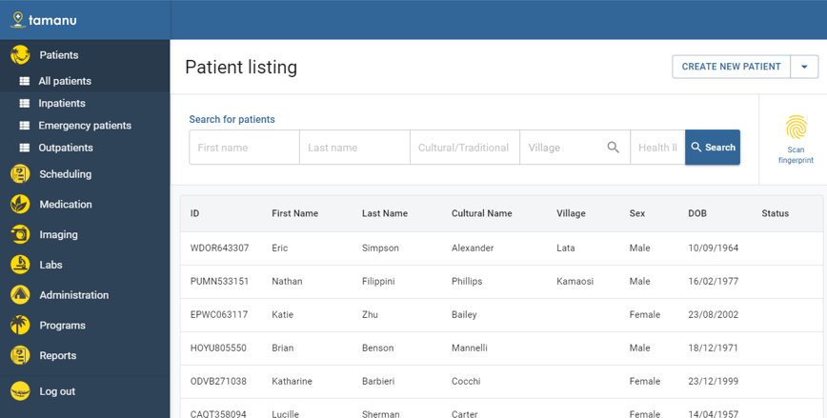
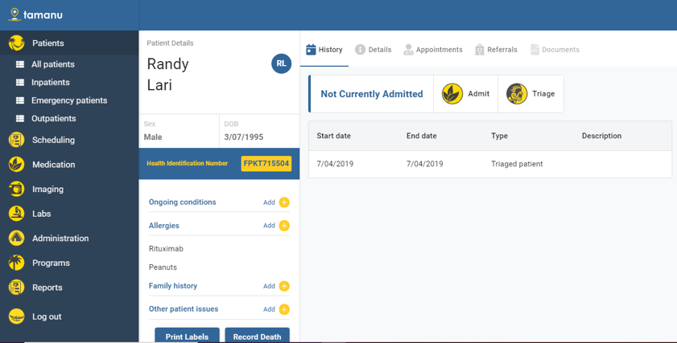
Patient desktop screenshot showing the ‘Patient listing’ and ‘Patient history’ screens.

We have also identified four software development priorities for the software in alignment with the shelf-readiness framework.
Tamanu's desktop client and server can currently be installed on a Windows PC from a zip file or by running an installer. There is no automatic update system in place for either the desktop or server components - this would be the next most important step in terms of product development.

As the communication between the Tamanu server and desktop client all happens through a JSON API, any external system capable of making HTTP requests could communicate with Tamanu as capably as the desktop client does. Currently the API documentation only exists in the form of test specifications, however future work here would include writing up more structured documentation with a focus on explaining architecture and outlining how to achieve particular use cases, rather than just detailing data structures.

We have taken care to follow industry best practices around security in Tamanu's development, but we have not engaged security experts to audit the architecture or codebase or conduct any penetration testing. These would be the ideal next steps to improve Tamanu's security.

Tamanu is designed to be used in smaller settings, where a single well-specified on-site server could handle the requirements of the facility. The central server that manages synchronisation between on-site servers is in its early stages, and further work is required on scalability.

Digital Health Technologies
Tamanu is an EMR system for mobile (React) and desktop (in Electron), with complete offline functionality and syncing capabilities. The data gathered in Tamanu will be aggregated through local DHIS2 instances (almost every country in the Pacific is now using DHIS2) and in turn to Tupaia (a regional DHIS2 platform that uses DHIS2 for data aggregation but then configures the data and displays it through a React front-end).

The Tamanu deployment architecture is displayed below.

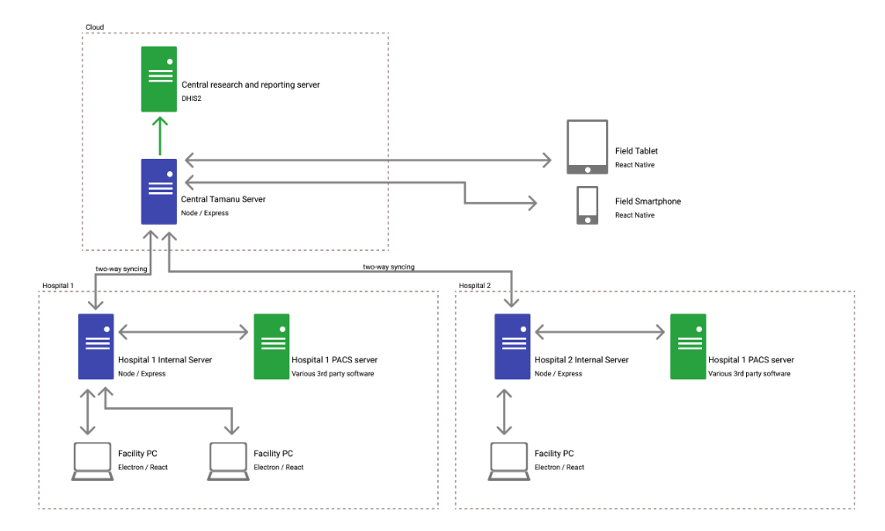
Tamanu Deployment Architecture

Tamanu uses the internationally recognised ICD10, International Statistical Classification of Disease and Related Problems (ICD), a medical classification list by the WHO, and CPT, Current Procedural Terminology, coding for diagnoses and procedures. Alternative or additional codes can also be imported.

The longer-term goal is to integrate Tamanu with a Laboratory Information Management System (LIMS) and a radiology Picture Archiving and Communication System (PACS). These integrations will create a seamless and efficient workflow for clinicians requesting laboratory and radiology tests. We are rapidly building out the accompanying LIMS for Tamanu in partnership with Naralabs of Spain and their software SENAITE.

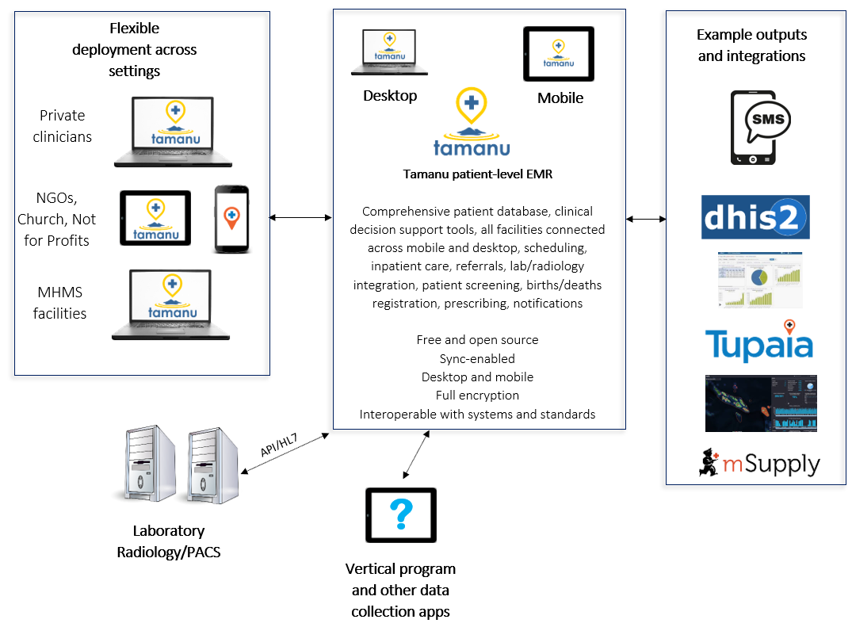

Tamanu Ecosystem

Use Cases and User Stories
User Story – Continuum of Care
In rural Samoa, a 30 year old male presents to a clinic with a persistent cough and is seen by a nurse, who enters an episode of care into her mobile EMR and refers him to hospital. At the hospital, a doctor sees him in emergency and brings up his medical record on the laptop computer in the department.

The internet has been down all morning but the patient’s notes have synced to her local instance overnight and she is able to view his most recent presentation and make changes to the patient record. She sees this is the second presentation with a persistent cough and she notes weight loss over a 12-month period. She orders a sputum sample and a chest x-ray.

The next day she brings up the results of these two investigations on her computer and makes a confident diagnosis of TB. She commences treatment and admits the man onto the TB ward. A warning alerts her to the fact the man should be screened for HIV as well – she orders a test, which is negative and this is attached to his electronic record.

The diagnosis is reported from Tamanu to DHIS2 and the TB/HIV team is automatically alerted to the fact that this is the third diagnosis of TB from that village in a short space of time. Along with a contact tracing officer, they send an environmental health officer to assess living conditions in the village.

After completing the first stage of treatment, the patient is transferred back to their home clinic for follow-up care and continuing DOTS therapy. The patient cannot remember the name of what he has been diagnosed with or his ongoing treatment needs but the local nurse is able to bring up his patient record again on her phone and continue therapy. Her Mobile EMR sends the man a text message in his local language that explains his condition and the need to continue taking medicine for several more months. He continues to receive weekly reminders until the completion of therapy.

Use Case – Targeted Initiatives
Atoifi General Hospital in Solomon Islands will be implementing Tamanu as part of a project to monitor diagnosis and treatment of malaria.

Use Case - Tamanu Lab
We are rapidly building out the accompanying Laboratory Information Management System for Tamanu in partnership with Naralabs of Spain and their software SENAITE. We are taking this free and open-source system, which has been widely deployed around the world and adapting it for the Pacific setting. We are doing this with the support of DFAT and funding as a sub-recipient of the Burnet Institute on another grant they have in PNG. We expect the first deployment to occur in the third quarter of 2020, once testing and training is complete.

The system for deployment will be called Tamanu Lab and it will harness all of the features and experience of SENAITE but adapted for the unique setting of the Pacific. The system will be free and open-source and will sync with Tupaia (which several countries are using). We also aim to incorporate the feature requests below, as outlined several months ago - these include interfaces with equipment, interoperability with other software and data visualisations.

The benefits that this development could bring to clinicians is invaluable. The system will interface with Tamanu to create a complete laboratory workflow from the doctor ordering the test result to the doctor receiving the result. This will improve the efficiency of the laboratories workflows and the timeliness of doctors receiving critical results.

Objectives and Activities
In order to address the problem statement, we have implemented stringent processes entailing testing and documentation. Development on the backend is progressing using a test-driven approach, so we can move quickly while still being confident that the software works as expected. The frontend is tested manually, but with a component-driven approach so new screens can be assembled and rearranged without requiring large changes to the application. All changes go through a peer-review process to catch any code-level issues. Through this process we hope to ensure that the software is clinically and technically optimal.

Work package 1: Easy Installation and Deployment

Objective 1.1: Automated Updates
Neither the desktop client or LAN server have an automated update process. The manual update is straightforward - simply run the installer to install the updated software over the top of the previous version. There is no check within the application to see if a new version is available or to download it.

Currently the installers for LAN and desktop are only available via a protected S3 bucket. The plan to provide better updates includes the following activities.

Activity 1.1.1: Set up publicly visible website that provides links to download the latest versions.

Activity 1.1.2: Update the LAN server to inform connected desktop clients if they are using an outdated version of the software (compared to the version of the LAN server), and to display a link to download the appropriate version if so.

Activity 1.1.3: Add a simple API to the website that says what the latest versions of each software package are.

Activity 1.1.4: Update the LAN server to periodically check the website to see if a newer version is available and update the desktop client to display an update notification (with a link) to administrators whenever the LAN server detects that it is running outdated software.

Activity 1.1.5: Implement functionality to have the desktop client automatically update itself based on a link provided by the LAN server.

Activity 1.1.6: Implement functionality to have the LAN server automatically update itself based on the version information from the website.

Each of these steps provides individually-useful functionality, so this plan doesn’t need to be implemented as part of a single unit of work – effort on this could be spread out and interleaved with development in other areas.
Dependencies: Automatic updates are an attack vector for hackers, and it’s likely that this plan would be subject to change to accommodate defenses against this, based on advice from an IT security contractor.

Objective 1.2: Packaging and Installation

Activity 1.2.1: Database Updates – By default, the system uses SQLite as a database, as it is very lightweight and doesn’t require additional setup. Performance and security improvements are possible by switching to Postgres, which the LAN server natively supports.

Activity 1.2.2: Security Measures - Unless otherwise configured, the LAN server also communicates with desktop clients over plain HTTP. This means data is easily readable by a third party - it’s important that an encryption layer is set up at any site using actual patient data. Currently this is achievable by running the LAN server behind an HTTPS proxy (for eg, nginx).

Alternatively, there are plans to add native HTTPS support to the LAN server. However, this would still require an administrator to provide a signed third-party certificate to manage that encryption (including a certificate with the Tamanu download would be self-defeating, as an attacker could trivially obtain the same certificate).

Activity 1.2.3: There has been some thought given to providing a Docker image containing a pre-configured LAN server with a Postgres database & HTTPS proxy. It wouldn’t provide a complete solution, however, as any administrator would still need to configure Docker on a host machine.

Documentation for configuring nginx, postgres and docker are all available online, and none of them are particularly unusual tasks for a system administrator, but there is nothing in the Tamanu documentation that points the user to these instructions or describes how Tamanu should be set up to use them.

Dependencies: The security audit might require changes to the planned deployment & update process.

Work package 2: Thorough API Documentation

Objective 2.1: Documentation Website
Currently, all of the documentation for Tamanu exists as readme files in the code repository, and are not accessible outside of that. The following activities will be completed to ensure thorough and accessible documentation.

Activity 2.1.1: Establish a documentation website through GitHub Pages, and use a documentation generation tool (e.g. Read the Docs) to pull the existing documentation in the repo onto that website.

Activity 2.1.2: Add in-code documentation to each model and endpoint in the API, which the docs generator would automatically catch and display on the website. A paragraph explaining each model and how it fits into the Tamanu ecosystem, and a sentence or two plus an example for each endpoint in the API.
Dependencies: The security audit and performance tests might highlight issues that require modifications to the API.

Work package 3: Secure System
At this current stage, the development process has not benefitted from anyone with specific security training. The follow activities will be taken to ensure Tamanu is a secure system.

Objective 3.1: Expert Review

Activity 3.1.1: Recruit a security professional to conduct a high-level audit of the system’s architecture to identify any flaws.

Activity 3.1.2: Recruit a security professional to conduct an audit of the source code.

Objective 2.2: Penetration Testing

Activity 3.2.1: Once the security system has been further developed, penetration testing will be conducted.

Community Feedback
We intend to build and nurture a Pacific Island based community of software developers, software maintenance teams and eHealth project managers, overseen and funded by a consortium of regional donors. Experienced software developers are increasing in number across the Pacific but – particularly in eHealth – they have tended to work in silos, often creating small-scale, bespoke software solutions that have proven unsustainable or ineffective. There is not a lack of talent but a lack of connectivity between these developers and global projects. Consequently, especially for implementations of DHIS2, consultants are usually brought in from Europe or elsewhere in Asia and there is a lack of knowledge-transfer.

We believe we can foster a Pacific-based community of developers and bring them into the global eHealth community. This can be delivered by a joint mSupply Foundation/BES initiative called the Health & Supply Chain Data and Technical Assistance Centre (DTAC), a new five-year project funded by the New Zealand government. DTAC aims to provide support in mSupply, DHIS2, Tamanu and other eHealth initiatives in the region, with a focus on developing south-south peer networks.

This would allow countries to implement software but engage tech support, debugging, implementation and customizations from a local pool of developers. Tupaia is an example of this – a regional customization of DHIS2 that has been completed predominantly by software developers in New Zealand. We aim to expand this developer community into countries such as Fiji, Vanuatu and PNG, with others to potentially follow. This community would work as a satellite to larger global communities involved with the development and maintenance of (primarily) DHIS2 and Tamanu. Initially, it could be run as a loose consortium of individuals, coordinated by DTAC.

Deliverables
Deliverable | Month/Quarter Due
Work Package 1, Objective 1, Activity 1 Output – Finalized link to publicly visible website | Q3 2020
Work Package 1, Objective 1, Activity 2 Output – Demonstrate link for download of updated system | Q3 2020
Work Package 1, Objective 1, Activity 3 Output – Finalized link to publicly available website | Q3 2020
Work Package 1, Objective 1, Activity 4 Output – Demonstrate message to alert that version is out of date | Q4 2020
Work Package 1, Objective 1, Activity 5 Output – Show functionality that enables automatic update | Q4 2020
Work Package 1, Objective 1, Activity 6 Output - Show functionality that enables automatic update | Q4 2020
Work Package 1, Objective 2, Activity 1 Output – Show coding for Postgres update | Q3 2020
Work Package 1, Objective 2, Activity 2 Output – Show coding that supports security | Q4 2020
Work Package 1, Objective 2, Activity 3 Output – Show documentation for Tamanu docker setup | Q4 2020
Work Package 2, Objective 1, Activity 1 Output – Provide link to GitHub pages | Q4 2020
Work Package 2, Objective 1, Activity 2 Output – Show finalized coding | Q4 2020
Work Package 3, Objective 1, Activity 1 Output – Demonstrate recruitment of security professional | Q1 2021
Work Package 3, Objective 1, Activity 2 Output – Show results of source code audit | Q1 2021
Work Package 3, Objective 2, Activity 1 Output – Show results of penetration testing | Q2 2021

Global Good Maturity Model Assessment
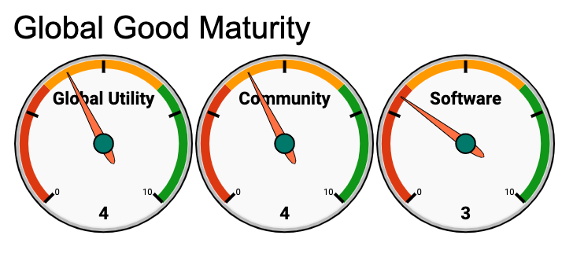
Link to Global Goods Maturity Assessment.

