Letter of Commitment

December 20, 2019

ACCESS Health International
1016 Fifth Avenue, Suite 11A/C
New York, New York
United States 10028

Mediterranean Shipping Company South East Asia (Singapore) Pte. Ltd.
Stamford Court, #04-01/07
61 Stamford Road
SINGAPORE 178892

Re: Digital Square RFA 2019-20 Digital Financial Services on Health Outcomes and Health Services

This letter is my commitment to ACCESS Health International, that should ACCESS Health become successful in obtaining a contract from Digital Square for RFA 2019-020 Digital Financial Services on Health Outcomes and Health Services, I will be available to begin work on this project upon execution of the contract and project.

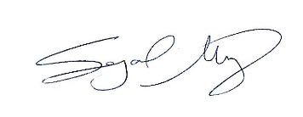

Signed: _______________________________________ Date: ___20 December 2019__

Printed Name: _Sejal Gopal Mistry___________

